Right to information –
Guide for authorities
when taking fingerprints
for Eurodac

Asylum applicants and migrants apprehended at the external border have a duty to give their fingerprints. When their fingerprints are taken, persons have the right to understand who is processing their personal data and why. They have the right to know what data are stored and for how long. They should know how to access it, correct and erase their data, in case of mistakes and whom to contact for these purposes.

In practice, officers find it challenging to give information on all aspects of the data processing at the time when taking fingerprints. People are often unaware why they give their fingerprints and what happens to these.

This leaflet assists officers and authorities to inform asylum applicants and migrants in an understandable and accessible way about the processing of their fingerprints in Eurodac.

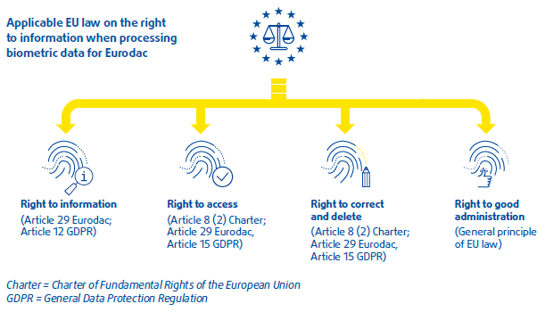

What is Eurodac?
Eurodac stands for European Asylum Dactyloscopy -it stores, processes and compares the fingerprints of asylum applicants and migrants apprehended at the external border.
It helps to identify the EU Member State responsible to examine an asylum claim. In the future, besides fingerprints, it will store the name, the facial image and other personal data.

FRA work with asylum applicants notes that information is most effective when:
→ It is provided both in writing as well as orally.
→ An interpreter is present or is easy reachable for questions.
→ A copy of the personal data collected is provided. This helps to exercise the right to access and the right to delete and correct the data.

How to provide information?
Information must be:
→ provided at the time when fingerprints are taken;
→ concise, transparent, comprehensible and in easily accessible format;
→ written in clear and plain language, adapting this to the needs of vulnerable persons, such as children;
→ provided, where necessary, orally;
→ in a language that the person understands.
Source: Eurodac Regulation 603/2013 (Article 29),
General Data Protection Regulation 2016/679 (Article 12).

What can you do?
→ Make the European Commission’s standard leaflet on the Dublin procedure available in relevant languages.
→ Develop easy-to-understand material
(e.g. leaflets, videos, posters).
→ Have the information available electronically and highly visible on the controller's website.
→ Repeat information, for example through
group information sessions.
→ Supply some key information orally in a simple way (e.g. information tagged with the speaker symbol ).

What information
to give?
EU law requires giving the following information:

Explain that it is an obligation to give fingerprints
for every asylum applicant and migrant above 14 years of age. These are recorded in an EU fingerprint database (EURODAC).
Explain what is stored
ten digital fingerprints, the gender, the country fingerprinting, the place and date of the asylum application (if applicable). No other personal data are stored. In case more personal data are collected by the authorities, for national purposes, e.g. name or age, migrants should be informed about the importance to provide accurate data.
Inform that fingerprints are kept for 10 years (if asylum seeker) or for 18 months (if an irregular migrant). After that, Eurodac automatically deletes the data.

Indicate that competent asylum and immigration authorities can access the data.

Communicate why fingerprints are collected
For example ‘’we take your fingerprints to see which EU country is responsible to decide whether you have a right to stay or not. If you move to another EU country without authorization, you risk being sent back to the country where you first registered.’’
Indicate that the police and the European Union’s Law Enforcement Agency (Europol) can access the data under strict conditions.
This is to prevent, detect, and investigate terrorist and other serious criminal offences. The country of origin cannot access the data.

Supply information on the person’s rights:
― to access and obtain a copy of the data and to correct and delete it, if there are mistakes
Inform about the procedure to follow:
whom to contact, how and the timeline of a response. The data controller is in charge.
― to make a complaint.
Inform about the procedure to follow:
for this purpose, provide the contact details of the National Data Protection Supervisory Authority, in charge of protecting the data.

Children
Children are in a particular vulnerable situation and need special attention. For Eurodac purposes, only the collection of fingerprints of children who are 14 years old or older is legal. Children have the same rights as adults over their personal data. Children under 18 years of age have the right to be informed in a child-friendly manner. You should:
→ Smile, be friendly, polite, empathic and attentive.
→ Adjust the approach and language to the children’s age.
→ Speak clearly enough that children can hear you properly.
→ Use visual aids such as videos or child-friendly leaflets.
→ Check that children have understood the information you gave.
→ Have the parent, the guardian and/or a person of trust accompanying the child.

Inability and refusal to give fingerprints
Asylum applicants and migrants with physical impairments may not be able to provide their fingerprints. Others could refuse to provide them. In case of non-compliance to provide fingerprints, repeated provision of information and effective counselling can reduce the risk to resort to coercive measures. In this context, see: FRA Fundamental rights implications of the obligation to provide fingerprints for Eurodac.

Sources
― Regulation (EU) No 603/2013 of 26 June 2013 on establishment of Eurodac (recast) OJ 2013 L 180/1 (Eurodac Regulation).
― Regulation (EU) 2016/679 of 27 April 2016 on the protection of natural persons with regard to the processing of personal data on the free movement of such data, and repealing Directive 95/46/EC OJ 2016 L 119/71 (General Data Protection Regulation).
― Commission Implementing Regulation No. 118/2014 of 30 January 2014 amending Regulation No 1560/2003 laying down detailed rules for the application of Council Regulation (EC) No 343/2003 establishing the criteria and mechanisms for determining the Member State responsible for examining an asylum application lodged in one of the Member States by a third-country national, OJ 2014 L 39/1, Annexes X to XII. (Commission Information Leaflets on Eurodac)
― FRA- EDPS-CoE-ECtHR (2018), Handbook on European Data Protection Law, 2018 edition.
― FRA (2015), Fundamental rights implications of the obligation to provide fingerprints for Eurodac.
― Commission Staff Working Document on Implementation of the Eurodac Regulation as regards the obligation to take fingerprints, SWD(2015) 150 final, Brussels, 27.5.2015.

